**TO DELETE SUBSCRIPTION TOPIC IN ACL PROFILE**

The Solace CLI commands used to delete the subscription is no <thing>

Solace-primary-0(configure/acl-profile/subscribe-topic) no exceptions list animals/domestic/*

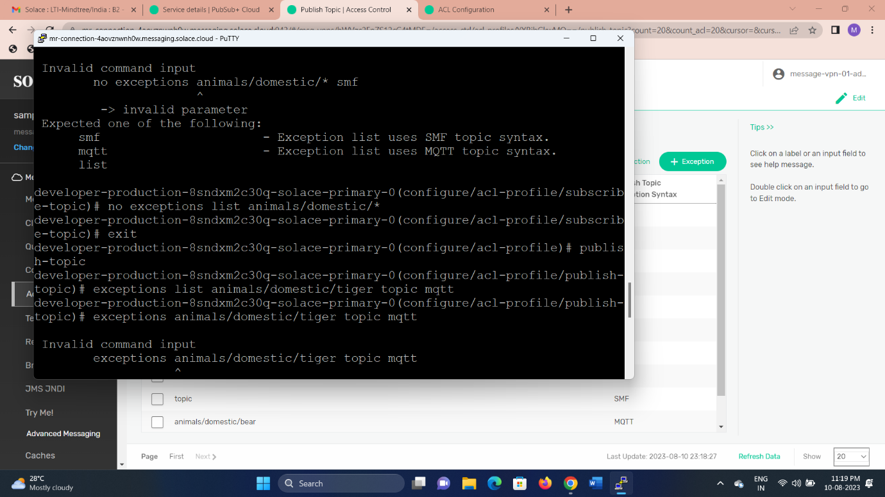

**AFTER DELETE SUBSCRIPTION**

